Call for
Expression of Interest
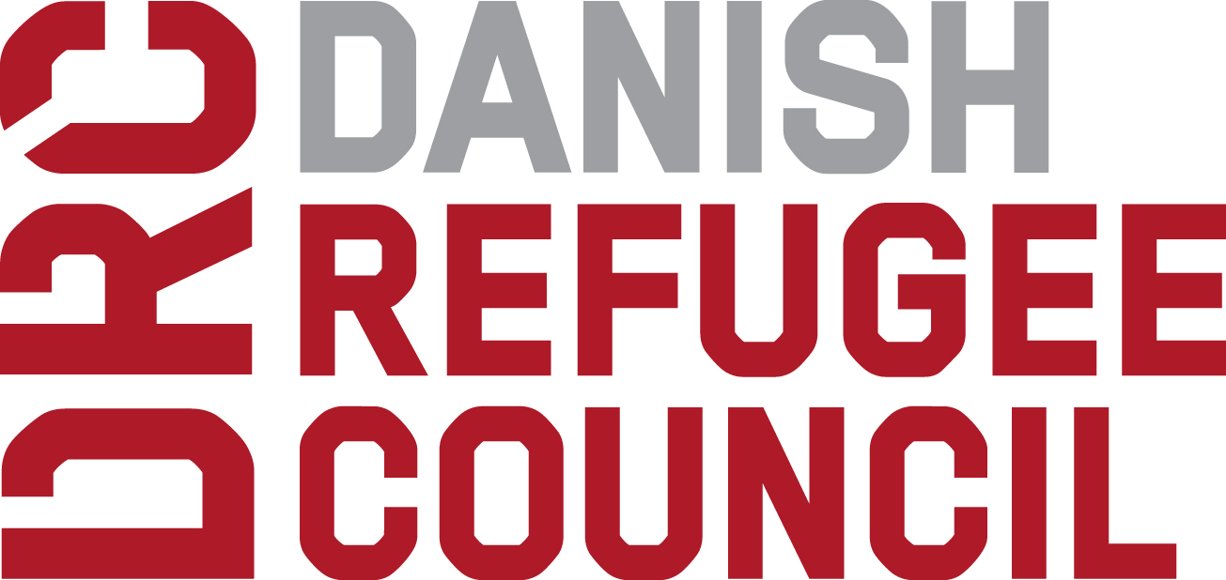

ANNEX A

EOI Application Form – MOBILE MONEY

ADMINISTRATIVE COMPLIANCE

Know You Customer (KYC)
Is your organization/company compliant with the country legislation on Know Your Customer (KYC)? Yes / No

What are the minimum documents required from individual clients to access the mobile money services you provide and other requirement? Do these requirements differ for (if so, please provide further detail):

- Nationals: ………………………………………………………………………….
- Foreigners: ………………………………………………………………………….
- Refugees: ………………………………………………………………………….
- Internally Displaced Persons:…………………………………………….
- Other Demographic Group:………………………………………………
What are the solutions you can provide for individual clients who do not comply with the minimum document requirements?
________________________________________________________________________________________

Authorization to work in Sudan

Is the company registered as a legal entity in the company register of Sudan? ◻ Yes / ◻ No (if yes, please provide the documentary proof of registration as a legal entity for Administrative evaluation)

In order to offer mobile money services, does the company operate directly, indirectly through intermediary organization(s) or both? ◻ Directly / ◻ Indirectly / ◻ Both

If indirectly or both, does the company have existing partnerships with intermediaries in Sudan? ◻ Yes / ◻ No (if yes, please provide documentary proof of registration as a legal entity in Sudan for all relevant intermediary partners for Administrative evaluation)

Does the company usually ensure intermediaries have the legal authorization needed to work in Sudan? ◻ Yes / ◻ No

If the company operates wholly or partially through intermediary(ies) but does not yet have existing partnerships in Sudan, might the company be willing and able to contract other intermediary organizations in Sudan? ◻ Yes / ◻ No

Might the company be able to work with an intermediary partner selected independently by DRC? ◻ Yes / ◻ No

If yes, please precise which type of intermediaries with which it might be possible to work?
◻ Banks
◻ Mobile money companies
◻ Micro-Finance institutions
◻ Money Transfer companies
◻ Money transporters
◻ Traders / local sellers
◻ Other (please specify): _____________________

Legal and Commercial Binding

Does the company possess the ability to legally and commercially bind all branches and/or intermediary partners in the event of the signature of a framework contract between the DRC and the company. ◻ Yes / ◻ No / ◻ Not applicable (please specify reasoning)
Additional comments:
____________________________________________________________________________________________________________________________________________________________________________
____________________________________________________________________________________________________________________________________________________________________________

TECHNICAL INFORMATION

Technical solution, type(s) of cash and/or voucher delivery mechanisms/payment systems provided

Do you already have the required network and technology for ensuring efficient and effective mobile money transfers? Yes / No

Would you need to develop new solutions to implement the proposed type and amount of transfers or adapt or rent another service through third party to be able to deliver the mobile money transfers? Yes / No

If so, how long would it take for you to set up the mobile money delivery mechanism in calendar days? ………..days

In order to deliver mobile money transfers, do you operate directly or indirectly through any intermediary organization(s)? Directly / Indirectly

What are the mobile money transfers services you can provide?
Direct mobile money transfers
Bulk Transfers
Restricted transfers to specific mobile Money account
Bank transfers
Other (please specify): _______________________

Network, presence and coverage across relevant geographical areas of operation for DRC’s cash and voucher assistance

Coverage of the mobile network to operate mobile money transfers in DRC’s Targeted areas are: (Please attach the list)
Areas |  | Network Coverage (Yes/no/partial)
White Nile
Khartoum
Al Jazeera
Gedaref
South Kordofan
Central Darfur

Total Number of Mobile Money cash out points in DRC’s Targeted AREAS: (Please attach the list)
Areas |  | Number of mobile money cash out points
White Nile
Khartoum
Al Jazeera
Gedaref
South Kordofan
Central Darfur

Total Number of Mobile Agents in DRC’s Targeted AREAS who can move around the area and ensure mobile money cash out: (Please attach the list)
Areas |  | Number of Agents
White Nile
Khartoum
Al Jazeera
Gedaref
South Kordofan
Central Darfur

Any other additional information about your network/ outreach:

If you do not have any delivery points, outreach, networking in any of DRC’s targeted areas, how would you rapidly respond and distribute cash and/or vouchers?

Capacity to deliver the volume of assistance requested by DRC

What are the minimum and maximum amounts of funds you can disburse in a day?
Minimum……………………… (amount) …………….. (currency)
Maximum……………………… (amount) …………….. (currency)

How much (in monetary value) cash and voucher assistance are you able to deliver in the programmatic areas targeted by DRC within 1 month (maximum amount)?
Areas |  | Value and Currency
White Nile
Khartoum
Al Jazeera
Gedaref
South Kordofan
Central Darfur

How long does it take to distribute cash via mobile money to 100 / 500 / 2,000 / 5000 people in the areas targeted by DRC programming once all recipients are registered?”
 |  | Time in days / hours?
Region |  | 100 people | 500 people | 2000 people | 5000 people
White Nile
Khartoum
Al Jazeera
Gedaref
South Kordofan
Central Darfur

Existing experience and competency in supporting delivery of humanitarian cash and voucher assistance in the country of programming

Do you have experience in humanitarian mobile money transfers? If yes, please provide a short description and list down the clients you have worked with and/or are working with on mobile money transfers including payment methods.
Name of the client | Payment Method | Total amount distributed | Targeted areas | Comments

Do you have any working experience with DRC? If yes, please describe this experience below (completed projects and / or ongoing projects):
Payment Method | Total amount distributed | Targeted areas | Comments

If you have no experience in humanitarian cash and voucher assistance programming, would you be interested in possible future involvement? Please describe your interest.

Please provide reference, including contact details, from at least one other NGO or international organisation proving experience and competency in supporting the delivery of humanitarian cash and voucher assistance.
Name of the NGO | Name of the contact | e-mail address | Telephone number | Period

Data Protection and Management

Does your organization have a Data Protection Policy? Yes / No

Is your company compliant with the European Union’s General Data Protection Regulation (“GDPR”) (Regulation (EU) 2016/679)? Yes / No

Additional information
Please include any additional information you want to add in this EOI.

